CSC Operations – ESA Framework – Ground Segment Operational Configuration

APPROVAL

|  |  |  |  |
| --- | --- | --- | --- |
| Title | CSC Operations – ESA Framework – Ground Segment Operational Configuration | | |
| Issue Number | ​1 | Revision Number | 2 |
| Author | Coordination Desk Team | Date | 18/03/2024 |
| Verified By | Coordination Desk T.O. | Date of Verification |  |
| Approved By | Head Copernicus Ground Segment Systems, H/EOP-GCY | Date of Approval |  |
| Approved By | Head Copernicus Ground Segment Services, H/EOP-GCS | Date of Approval |  |
| Authorized By | Head Copernicus Ground Segment and Data management Division, H/EOP-GC | Date of Authorization |  |

CHANGE LOG

|  |  |  |  |
| --- | --- | --- | --- |
| Reason for change | Issue Nr | Revision Number | Date |
| Updating Ground Segment Operational Configuration | 1 | 1 | 13/11/2023 |
| Updating Ground Segment Operational Configuration | 1 | 2 | 18/03/2024 |

CHANGE RECORD

|  |  |  |  |  |
| --- | --- | --- | --- | --- |
| Issue Number | 1 | Revision Number | 1 | |
| Reason for change | | Date | Pages | Paragraph(s) |
| Update list of Acronyms | | 13/11/2023 | 7 | 1.2 |
| Updated version of Master ICD document | | 13/11/2023 | 9 | 1.3 |
| Update description | | 13/11/2023 | 8 | 2 |
| Update CSC Configuration table:   * Renamed column “Operational IPF if applicable” in “Used Operational IPF if applicable” * Renamed row “Systematic Production and Quality Control” in “Production Services” * Renamed row “Data Preservation” in “LTA” * Renamed row “X-band Acquisition” in “Acquisition” * Delete row “Data Dissemination” * Renamed row “CDSE” in “CDSE (Data Access & Traceability)” * Delete row “Lv0 products Traceability service” | | 13/11/2023 | 10 and following | 3 |
| Updated Operational IPF | | 13/11/2023 | 9 and following | 3 |
| Updated Acquisition Stations Interface Point & Tailored ICD | | 13/11/2023 | 13, 14 | 3 |
| Added CDSE (Data Access & Traceability) service | | 13/11/2023 | 14 | 3 |
| Added S6 in the list of Satellites for POD | | 13/11/2023 | 15 | 3 |
| Updated version of ICD for S5P Consortium Acquisition | | 13/11/2023 | 12 | 3 |
| Update I&V matrix | | 13/11/2023 | 11 | 4 |
| Issue Number 1 | | Revision Number | 2 |  |
| Reason for change | | Date | Pages | Paragraph |
| Correction acronym INUS in INS | | 18/03/2024 | 7 | 1.2 |
| Added KSE in the list of acronyms | | 18/03/2024 | 7 | 1.2 |
|  | | 18/03/2024 | 7 | 1.2 |
| Updated version of Master ICD document  Update title of Master ICD document | | 18/03/2024 | 8 | 1.3 |
| Updated IPF version for S1A and S3B PSs (Serco) | | 18/03/2024 | 12 | 3 |
| Updated IPF version for S2A PS (ATOS) and S2B PS (CAPGEMINI) | | 18/03/2024 | 12 | 3 |
| Updated IPF version for S3A PS (ACRI) | | 18/03/2024 | 12 | 3 |
| Updated PDGS version for S5P PDGS (DLR) | | 18/03/2024 | 12 | 3 |
| Updated end of contracts for LTAs | | 18/03/2024 | 13 | 3 |
| Updated tailored SSC ICD | | 18/03/2024 | 14 | 3 |
| Detailed the information backup station and main station for each missions | | 18/03/2024 | 14 | 3 |
| Added mission S3 to SSC INUVIK ACQ | | 18/03/2024 | 14 | 3 |
| Add SSC Esrange ACQ | | 18/03/2024 | 14 | 3 |
| Update version of I&V matrix | | 18/03/2024 | 17 | 4 |

DISTRIBUTION

|  |
| --- |
| Name/Organisational Unit |
|  |

Table of Contents

1. Introduction 6

1.1. Purpose and Scope 6

1.2. Acronyms 6

1.3. Reference Documents 8

2. Context Overview 8

3. CSC Configuration 9

4. CSC INTERFACE MATRIX 16

1. Introduction
   1. Purpose and Scope

The scope of this document is to provide a ‘snapshot’ of the actual configuration of services belonging to Copernicus Space Component Ground Segment.

* 1. Acronyms

|  |  |
| --- | --- |
| **Acronym** | **Description** |
| ADGS | Auxiliary Data Gathering Service |
| AIP | Archive Interface delivery Point |
| AUXIP | Auxiliary Interface Delivery Point |
| BEDC | Backup EDRS Data Centre |
| CADIP | CADU Interface Delivery Points Specification |
| CDSE | Copernicus Data Space Ecosystem |
| CSC | Copernicus Space Component |
| DD | Data Dissemination |
| DDP | Data Delivery Point |
| DLR | Deutsches Zentrum für Luft- und Raumfahrt - German Aerospace Center |
| EDIP | EDRS Interface delivery Point |
| EDRS | European Data Relay System |
| E2E | End-to-End |
| FOS | Flight Operations Service |
| ICD | Interface Control Document |
| INS | Inuvik Ground Station - SSC |
| INTA | Instituto Nacional de Técnica Aeroespacial - National Institute of Aerospace Technology |
| IPF | Instrument Processing Facility |
| KSAT | Kongsberg Satellite Services |
| KSE | Esrange Ground Segment |
| L0 | Level 0 |
| L1 | Level 1 |
| L2 | Level 2 |
| LTA | Long Term Archive |
| MP | Mission Planning |
| MPC | Mission Performance Cluster |
| MPCIP | Mission Performance Cluster Service Interface Delivery Point |
| MPIP | Mission Planning Interface Point |
| MPS | Maspalomas Ground Station - INTA |
| MTI | Matera Ground Station – E-Geos |
| NEU | Neustrelitz Ground Station - DLR |
| PDGS | Payload Data Ground Segment (Sentinel) |
| PEDC | Primary EDRS Data Centre |
| POD | Precise Orbit Determination |
| SGS | Svalbard Ground Station - KSAT |
| SSC | [Swedish Space Corporation](https://sscspace.com/ssc-worldwide/ground-station-network/inuvik-satellite-station/) |

* 1. Reference Documents

[RD-1] CSC Operations ESA Framework Ground Segment Architecture ESA-EOPG-EOPGC-TN-7

[RD-2] ESA EO OPERATIONS FRAMEWORK (EOF)

CSC - GROUND SEGMENT MASTER ICD ESA-EOPG- EOPGC-IF-6 v 1.7

1. Context Overview

As described in [RD-01], the Copernicus Space Component Ground Segment is in charge of:

* The Sentinels spacecraft monitoring and control, including execution of all platform activities and the commanding of the payload schedules.
* Implementing the Sentinels mission observation scenario in line with the satellite and ground resources and constraints.
* Acquiring the Sentinel instruments payload data, processing, archiving and making resulting users’ level data available.
* Monitoring and reporting on the operations performance.
* Maintaining the operational system under configuration management and control.
* Collecting external auxiliary data from Cal & Val external services.

The transformation of the Copernicus Ground Segment, implemented between 2019 and 2022, has enabled a significant modernisation and streamlining of the CSC Ground Segment interfaces and operations leading to a massive increase of performance, availability, reliability and flexibility, as resumed in the below picture:

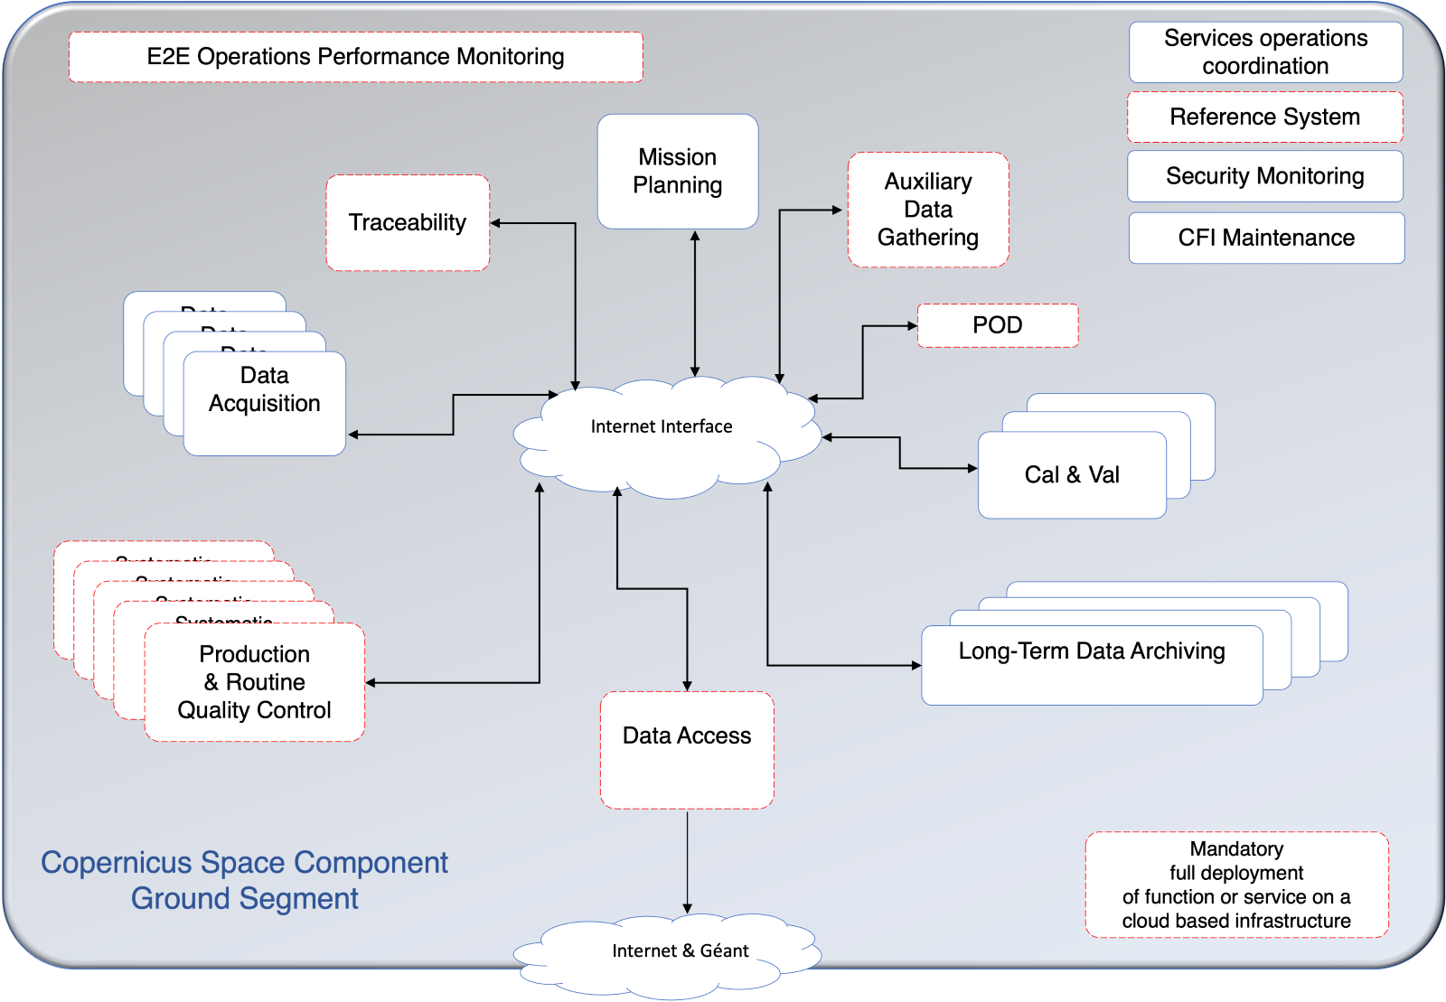  
Figure 1: CSC Ground Segment General Architecture

The transformed CSC Ground Segment operations involve today a large number of industrial services and external interfaces, all together contributing to CSC data flow.

Each service runs autonomously based on inputs available at the interface entry point and provides output by its interface to the other CSC services. A coordination layer across the various services provides a comprehensive E2E view of all Sentinel missions managed by ESA.

1. CSC Configuration

This section reports on the configuration of CSC Ground Segment Components.

The components can be grouped as follows:

1. CSC INTERFACE MATRIX

This matrix provides the existing interfaces between the different services.

